|  |  |  |  |  |  |  |  |  |
| --- | --- | --- | --- | --- | --- | --- | --- | --- |
| M | HTh | TTh | Th | H | T | O | Tths | Hths |
|  |  |  |  |  |  |  |  |  |

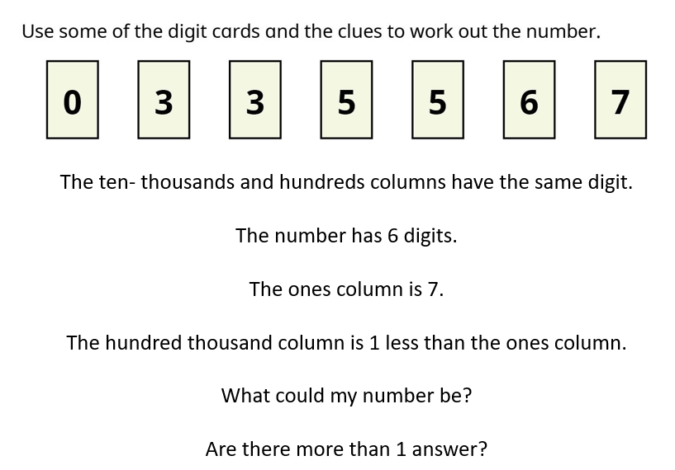

20000 ÷ 10 =

3254 ÷ 100 =

235 x 10 =

7456 x 100 =

63478 ÷ 100 =

10000 ÷ 100 =

230 x 100 =

63250 ÷ 10 =

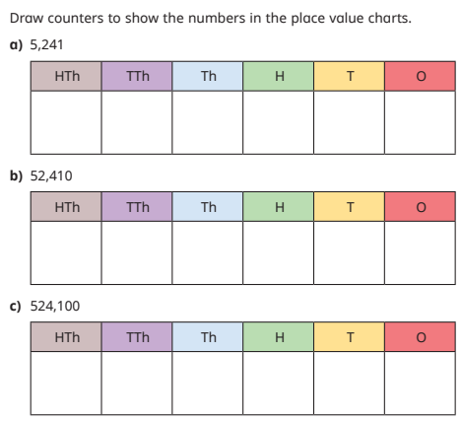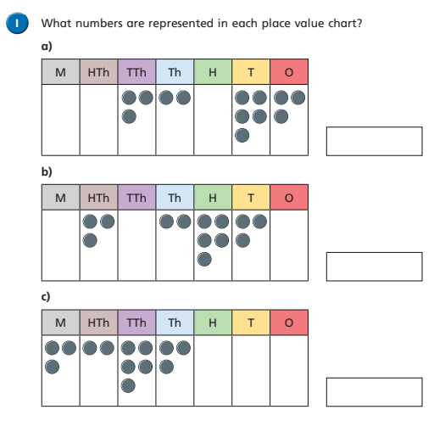

956,245

45,236

236,287