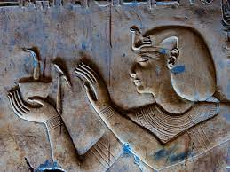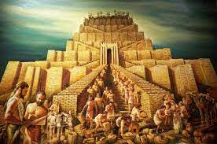**Year 4 Summer 2025**

**Ancient Civilisations**

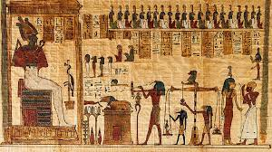

This term we will be delving into the history of three of the world’s first ancient civilisations: ancient Sumer, ancient Egypt and the Indus Valley civilisation. Children will learn about the rise, life, achievements and eventual end of each civilisation.

**Science**

Electrical Circuits and Conductors

This project teaches children about electrical appliances and safety. They construct simple series circuits and name their parts and functions, including switches, wires and cells. They investigate electrical conductors and insulators and identify common features of conductors. It also teaches children about programmable devices. They combine their learning to design and make a nightlight.

**Art and Design**

Statues, Statuettes and Figurines.

This project teaches children about the 3-D representation of the human form, including statues, statuettes and figurines. They study examples from ancient civilisations, and use their clay skills to create a Sumer-style figurine.

Islamic Art

This project teaches children about the features of Islamic art. They make geometric patterns and motifs on paper, with fabric and in clay. They use their learning to create a high relief clay tile, decorated with geometric patterns.

**Design and Technology**

Tomb Builders

This project teaches children about simple machines, including wheels, axles, inclined planes, pulleys and levers, exploring how they helped ancient builders to lift and move heavy loads.

**Maths**

This term we will be continuing to follow White Rose Maths. We will be consolidating our previous knowledge and using reasoning resources to cover these concepts,

* Decimals - Position and Direction
* Money - Statistics
* Time - Shape

**Literacy and Reading**

In Literacy and reading we will focus our learning around two amazing new books, *Where the Forest Meets the Sea* by Jeannie Baker and *Fantastically Great Women Who Saved the Planet* by Kate Pankhurst.

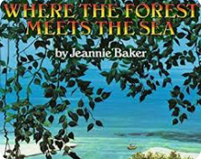



**Homework:**

Each week your child will have:

* 10 spellings to learn
* A short maths homework task.

These will be sent home on a Thursday and will need to be returned to school by the following Thursday.

In line with school policy, children are asked to complete 3 reads each week. Reading diaries will be checked each week on a Monday morning. Class 4 have a reading challenge encouraging children to read at least three times a week for ten minutes to an adult. When they have 50, 100, 150, 200 reads recorded they will receive a certificate and have their picture displayed on our reading board in the reception area. I know a few of our class have already achieved some of these, which is fantastic!

I hope you have all had a lovely Easter break and are ready to get stuck into this new topic as much as I am. LET’S GO BACK IN TIME!

As always thank you for your continued support.

Kind regards,

Mrs Allott and Year 4 team.